Developing Your One-page Profile with a Colleague
Workbook

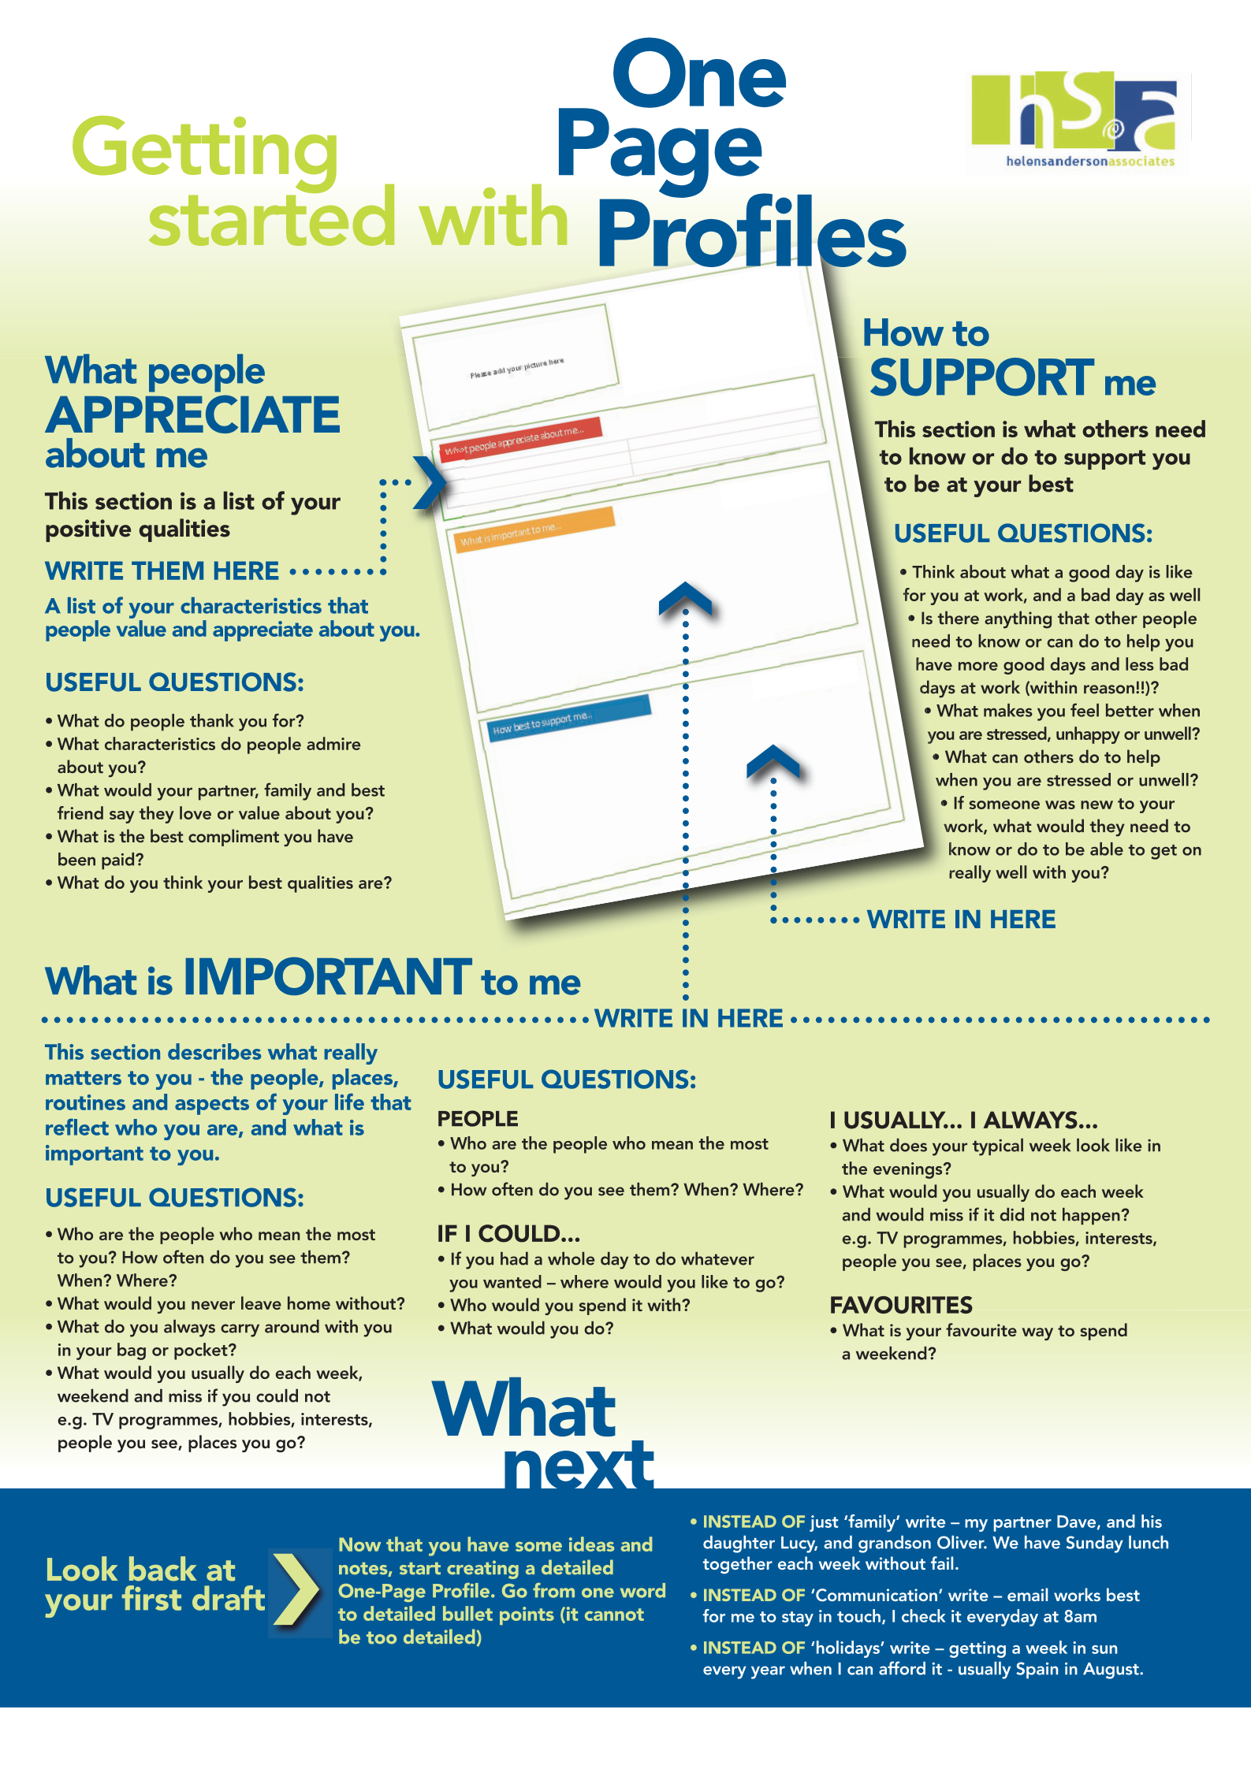
Using this Workbook

This workbook will take you through the process of writing your one page profile.

- If possible find a quiet and comfortable place to work where you won’t be interrupted
- Work through the booklet page by page
- Have a conversation with your colleague – ask each other the question and share what you feel comfortable with
- Take notes in the top box. You might want to swap books as you do this, taking notes for your colleague as they answer. Use the notes to come up with a few sentences that captures the information your colleague has noted and write this in the bullet pointed section below
- Check that the sentences are specific and detailed (the next page gives more information about this)
- Try to keep to the suggested times on each section if you want to complete your One Page Profile in an hour
- When you’ve completed all 6 questions, decide together which sentences you will add to the one page profile template. There is guidance on where on the template to put each bit of information

Before you start…

Text a family member, friend or colleague and ask them to tell you 3 things they like and admire about you then put your phone on silent and away until you get to page 9.

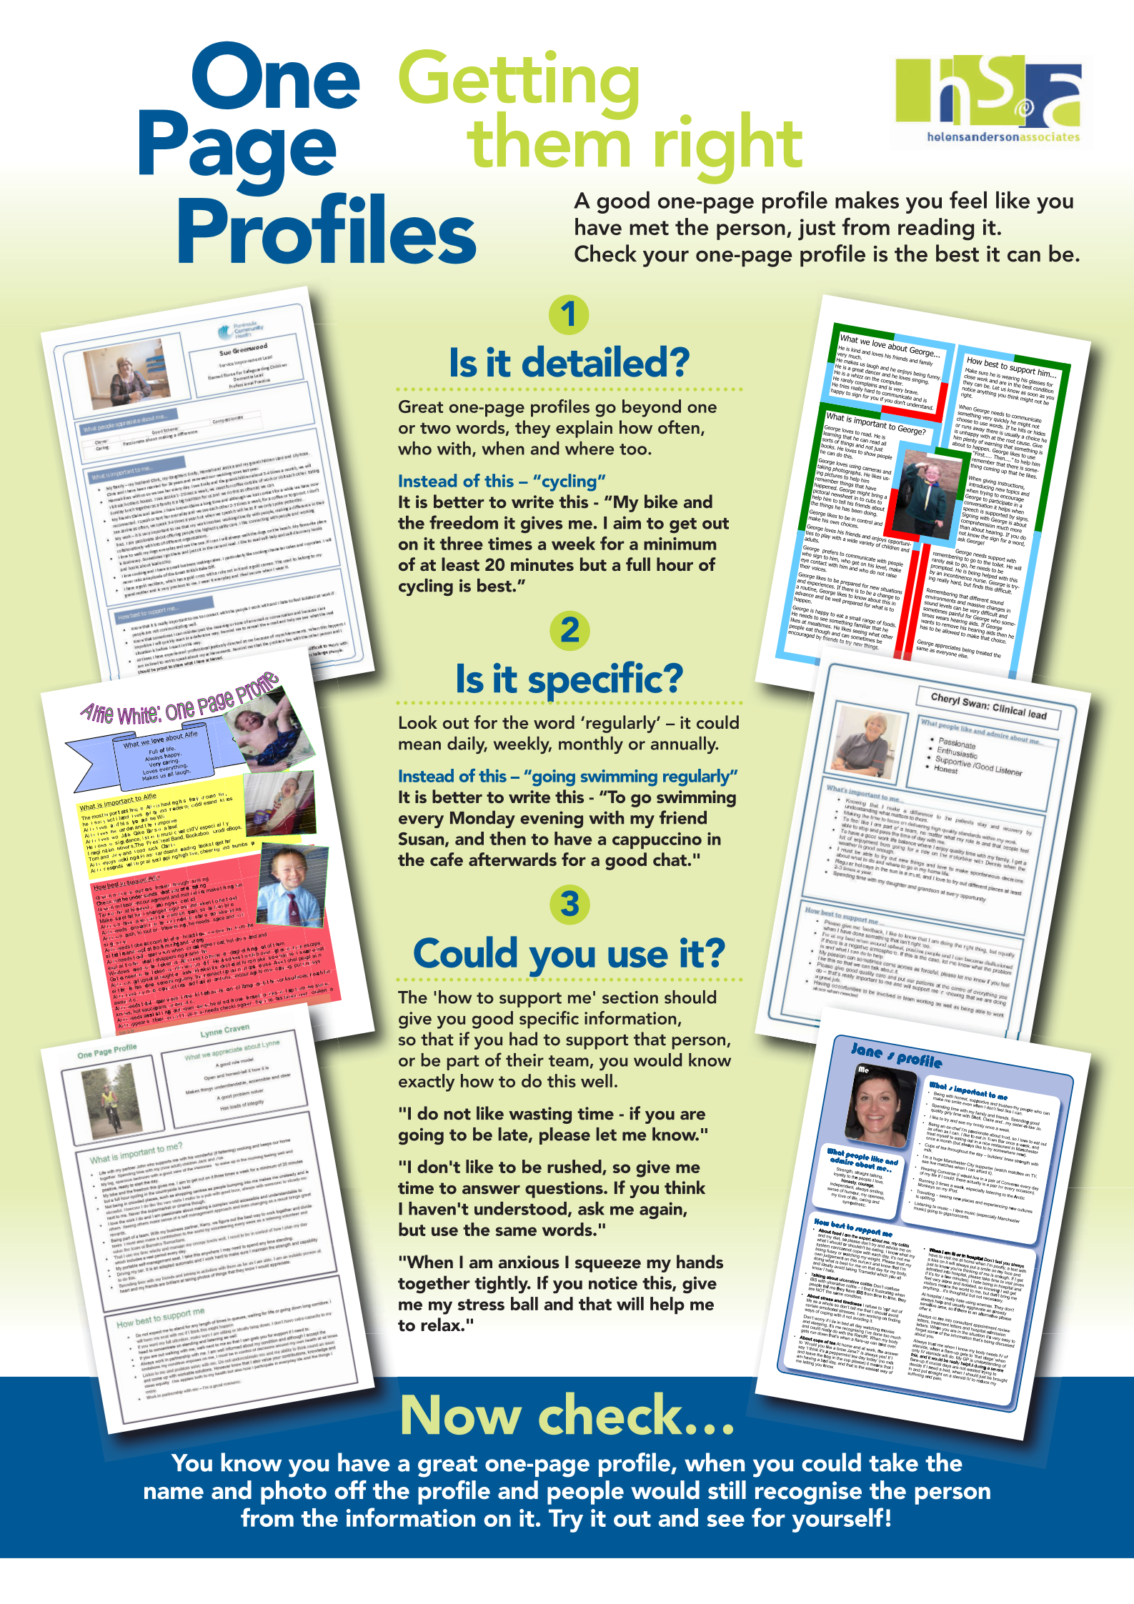
5 Mins
2 Mins
1 Min.

Now add to your one page profile template in
HOW BEST TO SUPPORT ME section
CHECK – EACH SENTENCE

Is it detailed?

Is it specific?

Could you use it?

Who are the most important people in your life? How often do you see them and what do you like to do together?

5 Mins

Now add to your one page profile template in
HOW BEST TO SUPPORT ME section
CHECK – EACH SENTENCE

Is it detailed?

Is it specific?

Could you use it?
1 Min.
Your sentences should be ‘know’ or ‘do’ instructions

What would make a good day for you at work and what would make a bad day for you at work – list 3 things for each.

2 Mins
1 Min.

Now add to your one page profile template in
WHAT’S IMPORTANT TO ME
section
CHECK – EACH SENTENCE

Is it detailed?

Is it specific?

Could you use it?
2 Mins

5 Mins
What do you usually do each day or week that you would miss if you didn’t do?

1 Min.
2 Mins
5 Mins

Now add to your one page profile template in
WHAT’S IMPORTANT TO ME
section
CHECK – EACH SENTENCE

Is it detailed?

Is it specific?

Could you use it?
Your sentences should be ‘know’ or ‘do’ instructions

What makes you stressed, unhappy or upset? How would people know and what can they do to help?

1 Min.
2 Mins
5 Mins
What are some of the things you can’t do without, the possessions you value and treasure?

Your sentences should be ‘know’ or ‘do’ instructions

CHECK – EACH SENTENCE

Is it detailed?

Is it specific?

Could you use it?

Now add to your one page profile template in
WHAT’S IMPORTANT TO ME
section

What would your family and friends say they like and admire about you?

If you texted at the beginning of the session get your phone out and see what your friend, family member or colleague has said about you…

What does your colleague think?

5 Mins
2 Mins

Now add to your one page profile template in
WHAT PEOPLE LIKE AND ADMIRE ABOUT ME
section

What is important to me…

Name
Please add your picture here

What people like & admire about me mmememe…

